**UPDATING CONTROL TABLE**

|  |  |  |
| --- | --- | --- |
| **Item** | **Description of the revision** | **Date** |
| 1 | Create new | 11/1/2020 |
|  |  |  |
|  |  |  |
|  |  |  |
|  |  |  |
|  |  |  |
|  |  |  |
|  |  |  |
|  |  |  |
|  |  |  |
|  |  |  |
|  |  |  |

|  |  |  |
| --- | --- | --- |
| **Issued or Updated** | **Checked** | **Approved** |
|  |  |  |

**MCU Performance Test**

1. **Purpose**

Characteristics and quality of a Motor Controller can be evaluated through the following test list, which will be explained more detail in the third section:

* Fast Efficiency Test to choose best value of R_gate 4 hours
* Power and Efficiency Test 10 hours
* Rated Power Operation Test 12 hours
* Max Power Operation Test 8 hours
* Gradient Test (attenuation disturbance test) 4 hours
* Re-generate Energy Test. 2 hours

From these tests, we can:

* Evaluate the temperature rise on motor controller when it operates in different modes.
* Measures performance, power and climbing ability.
* Evaluate operability and protection ability when motor operate at high speed.

1. **Prepare**

**Infineon dynamometer system**

* At Singapore
* Electromechanical + Fan
* Inertia of load:
* Electric motor/generator with coaxial atrain gauge torque measurement system
* Max. ???kW @ ??? rpm
* Max. ???Nm Torque

**Motor**

* Ashwoods Motor

**Other equipment need for the tests**

* Data acquisition system to log the following data: battery voltage, battery current, electrical power, torque, speed, mechanical power, temperature on the MCU’s heatsink.
* DC Power source that can supply DC voltage from 40V to 60V and max. current should be greater than 150A.
* A set of lead acid battery (48V – 100Ah) can be used instead of DC power source but it will be inconvenient because it will take too long time to charge
* Mechanical tools.
* Oscillo scope that has 1 channel to measure DC voltage and 1 to 2 channels for current measurement.
* Fan to cool down MCU and Motor after each test
* Thermometer to measure temperature on the MCU’s heatsink

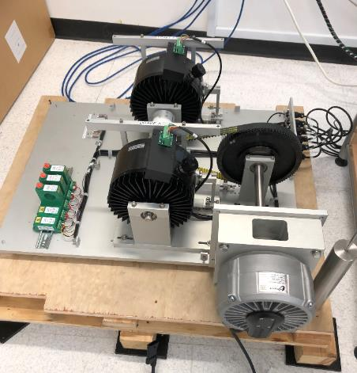

Infineon dynamometer system

1. **Measurement**
2. **Efficiency Test to choose best value of R_gate**

**Test goal:**

* To examine the dependence of system efficiency to the value of gate resistance.
* To evaluate the spike of Vds Voltage.
* As the result of this test, the best value of R_gate can be chosen.

**Test procedure:**

* MCU and Motor must be cooled down to ambient temperature before the test
* Setup the load to zero for the ability of motor free running
* Increase throttle level gradually to maximum and keep it at maximum level during the test.
* Increase load step by step gradually with the step size 1Nm, keep the load for 2 seconds in each step until the electrical power reaches rated power (3.5KW). Then keep torque constant in about 5 minutes or until the MCU protects because of over-temperature condition, enough to check the efficiency of the system with some values of R_gate.
* Log the following data for analysis: battery voltage, battery current, electrical power, torque, speed, mechanical power, temperature on heatsink of the MCU.
* Monitor DC voltage signal, DC current signal, phase current signal by oscillo scope and capture some pictures of these signal (if oscillo scope is available)

**Test conditions:** Do at least27 tests for Vinfast MCU as listed in the following table

|  |  |  |  |  |  |  |  |  |  |  |
| --- | --- | --- | --- | --- | --- | --- | --- | --- | --- | --- |
|  | | Thermal Pad: 12W/mK, U = 56V, Switching Freq = 16KHz | | | | | | | | |
| IPT012 | | | IPT015 | | | IPT020 | | |
| Eff.  (%) | Spike Vds  (V) | Vgs Slope  (V/us) | Eff.  (%) | Spike Vds  (V) | Vgs Slope  (V/us) | Eff.  (%) | Spike Vds  (V) | Vgs Slope  (V/us) |
| EPower  3.5KW  90km/h | R_gate1 |  |  |  |  |  |  |  |  |  |
| R_gate2 |  |  |  |  |  |  |  |  |  |
| R_gate3 |  |  |  |  |  |  |  |  |  |
| EPower  7.5KW  50km/h | R_gate1 |  |  |  |  |  |  |  |  |  |
| R_gate2 |  |  |  |  |  |  |  |  |  |
| R_gate3 |  |  |  |  |  |  |  |  |  |
| EPower  7.5KW  10km/h | R_gate1 |  |  |  |  |  |  |  |  |  |
| R_gate2 |  |  |  |  |  |  |  |  |  |
| R_gate3 |  |  |  |  |  |  |  |  |  |

**Table1: Fast efficiency tests to choose R_gate**

* Expected time for each test is around 5 - 10 minutes.
* Total time for this test is about 4 hours

**Equipment for Test:**

* Dynamometer with control software system.
* Data acquisition system to log the following data: battery voltage, battery current, electrical power, torque, speed, mechanical power, temperature on the MCU’s heatsink.
* Ashwoods motor.
* DC Power source that can supply DC voltage from 40V to 60V and max. current should be greater than 150A.
* A set of lead acid battery (48V – 100Ah) can be used instead of DC power source but it will be inconvenient because it will take too long time to charge
* Mechanical tools.
* Oscillo scope that have 1 channel to measure DC voltage and 1 to 2 channels for current measurement.
* Fan to cool down MCU and Motor after each test
* Thermometer to measure temperature on the MCU’s heatsink

**Test results:**

* An optimal value of gate resistance can be chosen for all latter tests

1. **Power and Efficiency Test**

**Test goal:**

* To examine characteristic and quality of the MCU device based on following parameters: DC voltage, DC current, phase current, electrical power, mechanical power, torque, speed and MCU’s heatsink temperature. Then the efficiency of the system consists of Motor and MCU can be calculated and analyzed.
* To compare quality of Vinfast MCU and MCU from Curtis.

**Test procedure:**

* MCU and Motor must be cooled down to ambient temperature before the test
* Setup the load to zero for the ability of motor free running
* Increase throttle level gradually to maximum and keep it at maximum level during the test.
* Increase load step by step gradually with the step size 0.2Nm, keep the load for 2 to 3 seconds in each step until the motor stops completely.
* Log the following data for analysis: battery voltage, battery current, electrical power, torque, speed, mechanical power, temperature on heatsink of the MCU.
* Monitor DC voltage signal, DC current signal, phase current signal by oscillo scope and capture some pictures of these signal (if oscillo scope is available)

**Test plan:**

|  |  |  |  |  |  |  |  |
| --- | --- | --- | --- | --- | --- | --- | --- |
|  | | Fsw = 16KHz | | | Fsw = 12KHz | | |
| IPT012 | IPT015 | IPT020 | IPT012 | IPT015 | IPT020 |
| Thermal Pad 6.2W/mK | Vdc = 56V |  |  |  |  |  |  |
| Vdc = 50V |  |  |  |  |  |  |
| Vdc = 42V |  |  |  |  |  |  |

* Do the test for Vinfast MCU at least 18 times for some different condition as shown in the above table.
* Do the test for Curtis MCU at least 1 time.
* Expected time for each test is around 30 minutes.
* Total time for this test is about 10 hours

**Equipment for Test:**

* Dynamometer with control software system.
* Data acquisition system to log the following data: battery voltage, battery current, electrical power, torque, speed, mechanical power, temperature on the MCU’s heatsink.
* Ashwoods motor.
* DC Power source that can supply DC voltage from 40V to 60V and max. current should be greater than 150A.
* A set of lead acid battery (48V – 100Ah) can be used instead of DC power source but it will be inconvenient because it will take too long time to charge
* Mechanical tools.
* Oscillo scope that have 1 channel to measure DC voltage and 1 to 2 channels for current measurement.
* Fan to cool down MCU and Motor after each test
* Thermometer to measure temperature on the MCU’s heatsink

**Test results:**

* + Following graph is an example of the obtained data of the test

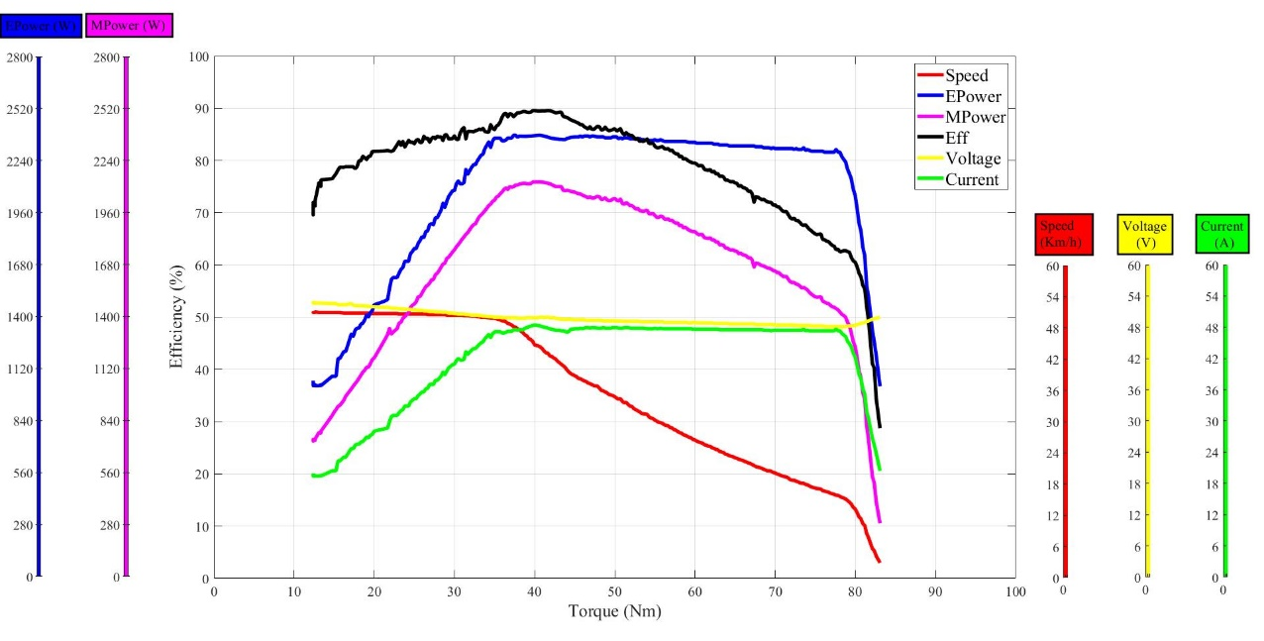

*Power and efficiency measurement*

* + Following is an example of the current and voltage signal

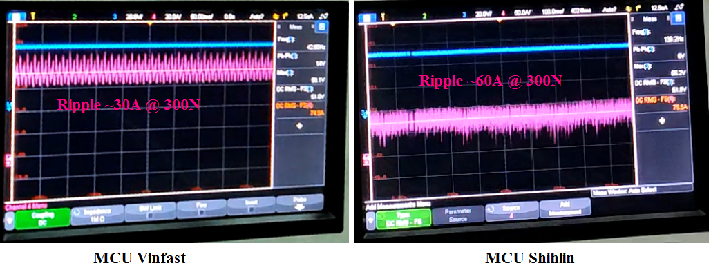

*DC Current Ripple at Load 50Nm*

1. **Rated Power Operation Test**

**Test goal:**

* To examine characteristic and quality of the MCU device when operating at rated power.
* Based on the measured parameters: DC voltage, DC current, phase current, electrical power, mechanical power, torque, speed and MCU’s heatsink temperature. Then the efficiency of the system and stable temperature of the MCU’s heatsink can be calculated and analyzed.
* To compare quality of Vinfast MCU and Curtis MCU.

**Test procedure:**

* MCU and Motor must be cooled down to ambient temperature before the test
* Setup the load to zero for the ability of motor free running
* Increase throttle level gradually to maximum and keep it at maximum level during the test.
* Increase load step by step gradually with the step size 0.5Nm, keep the load for 2 seconds in each step until the mechanical power reaches rated power (3.5KW). Then keep torque constant in about 1 hour, enough to check the ability of long-term operation.
* Log the following data for analysis: battery voltage, battery current, electrical power, torque, speed, mechanical power, temperature on heatsink of the MCU.
* Monitor DC voltage signal, DC current signal, phase current signal by oscillo scope and capture some pictures of these signal (if oscillo scope is available)

**Test plan:**

|  |  |  |  |  |  |  |  |
| --- | --- | --- | --- | --- | --- | --- | --- |
|  | | Fsw = 16KHz | | | Fsw = 12KHz | | |
| IPT012 | IPT015 | IPT020 | IPT012 | IPT015 | IPT020 |
| Thermal Pad 6.2W/mK | Vdc = 56V |  |  |  |  |  |  |
| Vdc = 42V |  |  |  |  |  |  |

* Do the test for Vinfast MCU at least 9 times for some different condition as shown in the above table.
* Do the test for Curtis MCU at least 1 time.
* Expected time for each test is around 75 minutes.
* Total time for this test is about 12 hours

**Equipment for Test:**

* Dynamometer with control software system.
* Data acquisition system to log the following data: battery voltage, battery current, electrical power, torque, speed, mechanical power, temperature on the MCU’s heatsink.
* Ashwoods motor.
* DC Power source that can supply DC voltage from 40V to 60V and max. current should be greater than 150A.
* A set of lead acid battery (48V – 100Ah) can be used instead of DC power source but it will be inconvenient because it will take too long time to charge
* Mechanical tools.
* Oscillo scope that have 1 channel to measure DC voltage and 1 to 2 channels for current measurement.
* Fan to cool down MCU and Motor after each test
* Thermometer to measure temperature on the MCU’s heatsink

**Test results:**

* + Obtained data will show ability of the MCU when it operates at rated power (through stable temperature of MCU and efficiency of the system)

1. **Max Power Operation Test**

**Test goal:**

* To examine characteristic and quality of the MCU device when operating at max power.
* Based on the measured parameters: DC voltage, DC current, phase current, electrical power, mechanical power, torque, speed and MCU’s heatsink temperature. Then the efficiency of the system and stable temperature of the MCU’s heatsink can be calculated and analyzed.
* To examine how long the MCU can work before it derate power and cutoff when MCU temperature reach its temperature protection
* To compare quality of Vinfast MCU and Curtis MCU.
* The test will be implemented at some different speed: 80km/h, 50km/h, 30km/h, 10km/h and 5km/h (equivalent to 5942Rpm, 3714Rpm, 2228Rpm, 743Rpm and 372Rpm)

**Test procedure:**

* MCU and Motor must be cooled down to ambient temperature before the test
* Setup the load to zero for the ability of motor free running
* Increase throttle level gradually to maximum and keep it at maximum level during the test.
* Increase load step by step gradually with the step size 1Nm, keep the load for 2 seconds in each step until the motor speed reduces to desired speed (80km/h, 50km/h, 30km/h, 10km/h and 5km/h), at these speeds, power reaches its maximum. Then keep torque constant in about 20 minutes or when MCU stops because of MCU’s over temperature.
* Log the following data for analysis: battery voltage, battery current, electrical power, torque, speed, mechanical power, temperature on heatsink of the MCU.
* Monitor DC voltage signal, DC current signal, phase current signal by oscillo scope and capture some pictures of these signal (if oscillo scope is available)

**Test plan:**

|  |  |  |  |  |  |  |  |
| --- | --- | --- | --- | --- | --- | --- | --- |
| Thermal Pad 6.2W/mK | | Fsw = 16KHz | | | Fsw = 12KHz | | |
| IPT012 | IPT015 | IPT020 | IPT012 | IPT015 | IPT020 |
| 80km/h | Vdc = 56V |  |  |  |  |  |  |
| Vdc = 42V |  |  |  |  |  |  |
| 50km/h | Vdc = 56V |  |  |  |  |  |  |
| Vdc = 42V |  |  |  |  |  |  |
| 30km/h | Vdc = 56V |  |  |  |  |  |  |
| Vdc = 42V |  |  |  |  |  |  |
| 10km/h | Vdc = 56V |  |  |  |  |  |  |
| Vdc = 42V |  |  |  |  |  |  |

* Do the test for Vinfast MCU at least 72 times for some different condition as shown in the above table.
* Do the test for Curtis MCU at least 5 times at different speeds.
* Expected time for each test is around 10 to 20 minutes.
* Total time for this test is about 8 hours

**Equipment for Test:**

* Dynamometer with control software system.
* Data acquisition system to log the following data: battery voltage, battery current, electrical power, torque, speed, mechanical power, temperature on the MCU’s heatsink.
* Ashwoods motor.
* DC Power source that can supply DC voltage from 40V to 60V and max. current should be greater than 150A.
* A set of lead acid battery (48V – 100Ah) can be used instead of DC power source but it will be inconvenient because it will take too long time to charge
* Mechanical tools.
* Oscillo scope that have 1 channel to measure DC voltage and 1 to 2 channels for current measurement.
* Fan to cool down MCU and Motor after each test
* Thermometer to measure temperature on the MCU’s heatsink

**Test results:**

* + Obtained data will show ability of the MCU when it operates at max. power.

1. **Gradient Test (attenuation disturbance test)**

**Test goal:**

* To examine the ability of going up a slope with different gradient of the MCU device.
* Based on the measured parameters: DC voltage, DC current, phase current, electrical power, mechanical power, torque, speed and MCU’s heatsink temperature. Then the efficiency of the system and stable temperature of the MCU’s heatsink can be calculated and analyzed.
* To examine speed and current response of the controller when the load changes suddenly.
* To compare quality of Vinfast MCU and Curtis MCU.

**Test procedure:**

* MCU and Motor must be cooled down to ambient temperature before the test
* Setup the load 10Nm to simulate the first level gradient.
* Increase throttle level to maximum and keep at maximum level of the throttle during the test
* Increase load with the step of 10Nm, keep the load for 30 seconds in each step of the load until motor’s speed reduces below 500rpm. Then decrease load in similar condition when load is increased.
* Log the following data for analysis: battery voltage, battery current, electrical power, torque, speed, mechanical power, temperature on heatsink of the MCU.
* Monitor DC voltage signal, DC current signal, phase current signal by oscillo scope and capture some pictures of these signal (if oscillo scope is available)

**Test plan:**

|  |  |  |  |  |  |  |  |
| --- | --- | --- | --- | --- | --- | --- | --- |
|  | | Fsw = 16KHz | | | Fsw = 12KHz | | |
| IPT012 | IPT015 | IPT020 | IPT012 | IPT015 | IPT020 |
| Thermal Pad 6.2W/mK | Vdc = 56V |  |  |  |  |  |  |
| Vdc = 42V |  |  |  |  |  |  |

* Do the test for Vinfast MCU at least 18 times for use of different type of thermal pad (the test will also check which thermal pad can be used for 3.5KW MCU)
* Do the test for Curtis MCU at least 1 time.
* Expected time for each test is about 10 to 15 minutes.
* Total time for this test is about 4 hours

**Equipment for Test:**

* Dynamometer with control software system.
* Data acquisition system to log the following data: battery voltage, battery current, electrical power, torque, speed, mechanical power, temperature on the MCU’s heatsink.
* Ashwoods motor.
* DC Power source that can supply DC voltage from 40V to 60V and max. current should be greater than 150A.
* A set of lead acid battery (48V – 100Ah) can be used instead of DC power source but it will be inconvenient because it will take too long time to charge
* Mechanical tools.
* Oscillo scope that have 1 channel to measure DC voltage and 1 to 2 channels for current measurement.
* Fan to cool down MCU and Motor after each test
* Thermometer to measure temperature on the MCU’s heatsink

**Test results:**

* + Following is an example of the obtained data

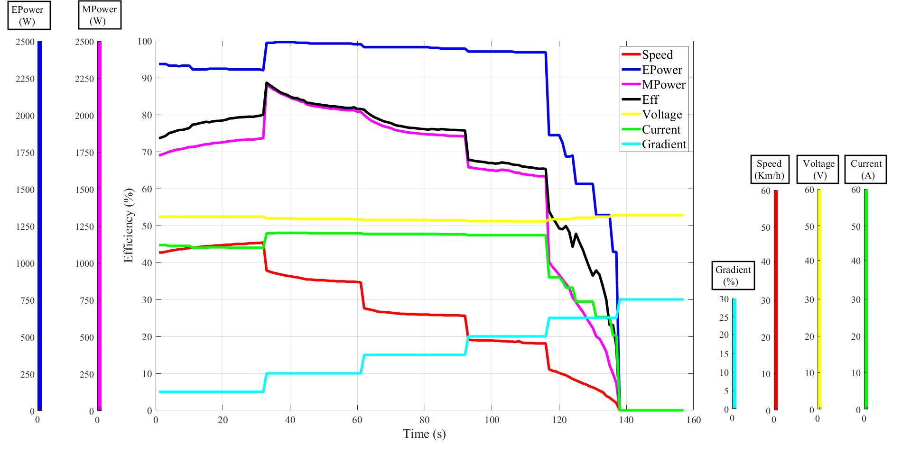

*Working at different gradients*

1. **Re-generate Energy Test.**
   1. **Activate electric brake at high speed (90km/h)**

**Test goal:**

* To check the ability of re-generating energy control and protection of the MCU when electric brake is activated at high speed.
* Based on the measured parameters: DC voltage, DC current, phase current, electrical power, mechanical power, torque, speed and MCU’s heatsink temperature. Then the ability of control and protection can be tested.
* To compare quality of Vinfast MCU and Curtis MCU.

**Test procedure:**

* MCU and Motor must be cooled down to ambient temperature before the test
* Setup the load to zero for the ability of motor free running.
* Increase throttle level to maximum and keep at maximum level of the throttle during the test
* Activate / inactivate brake signal to test charge current and protection function when DC bus voltage increase higher than over voltage protection threshold.
* The set of lead-acid battery may be used in this test because the DC power source cannot receive energy from motor.
* Log the following data for analysis: battery voltage, battery current, electrical power, torque, speed, mechanical power, temperature on heatsink of the MCU.
* Monitor DC voltage signal, DC current signal, phase current signal by oscillo scope and capture some pictures of these signal (if oscillo scope is available)

**Test plan:**

* Do the test for Vinfast MCU at least 1 time.
* Do the test for Curtis MCU at least 1 time.
* Expected time for each test is around 10 minutes.
* Total time for this test is about 30 minutes

**Equipment for Test:**

* Dynamometer with control software system.
* Data acquisition system to log the following data: battery voltage, battery current, electrical power, torque, speed, mechanical power, temperature on the MCU’s heatsink.
* Ashwoods motor.
* DC Power source that can supply DC voltage from 40V to 60V and max. current should be greater than 150A.
* A set of lead acid battery (48V – 100Ah) can be used instead of DC power source but it will be inconvenient because it will take too long time to charge
* Mechanical tools.
* Oscillo scope that have 1 channel to measure DC voltage and 1 to 2 channels for current measurement.
* Fan to cool down MCU and Motor after each test
* Thermometer to measure temperature on the MCU’s heatsink

**Test results:**

* + Oscillo scope will show DC Bus voltage and Current in this operation mode.

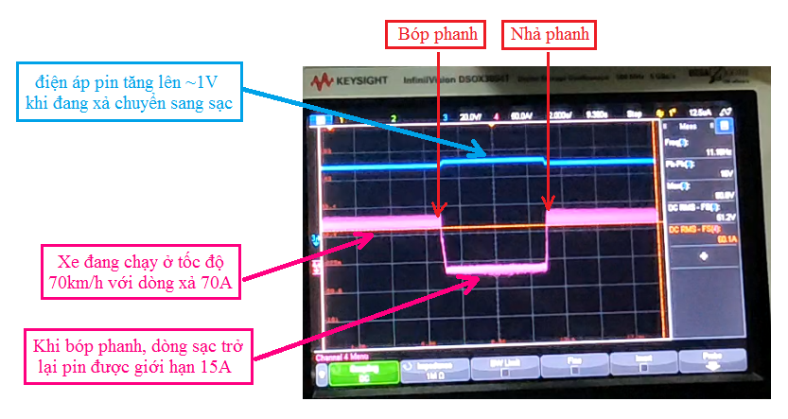

*DC Current and Voltage when activate brake at high speed (up to 90km/h)*

* 1. **Release throttle rapidly at high speed (90km/h)**

**Test goal:**

* To check response of the system when the throttle is released completely and rapidly, whether there is any current that tend to charge back to the battery or not.
* Based on the measured parameters: DC voltage, DC current, phase current, electrical power, mechanical power, torque, speed and MCU’s heatsink temperature. Then the ability of control and protection can be tested.
* To compare quality of Vinfast MCU and Curtis MCU.

**Test procedure:**

* Setup the load to zero for the ability of motor free running.
* Increase throttle level to maximum, then release it suddenly and completely
* The set of lead-acid battery may be used in this test because the DC power source cannot receive energy from motor.
* Log the following data for analysis: battery voltage, battery current, electrical power, torque, speed, mechanical power, temperature on heatsink of the MCU.
* Monitor DC voltage signal, DC current signal, phase current signal by oscillo scope and capture some pictures of these signal (if oscillo scope is available)

**Test plan:**

* Do the test for Vinfast MCU at least 1 time.
* Do the test for Curtis MCU at least 1 time.
* Expected time for each test is around 10 minutes.
* Total time for this test is about 30 minutes

**Equipment for Test:**

* Dynamometer with control software system.
* Data acquisition system to log the following data: battery voltage, battery current, electrical power, torque, speed, mechanical power, temperature on the MCU’s heatsink.
* Ashwoods motor.
* DC Power source that can supply DC voltage from 40V to 60V and max. current should be greater than 150A.
* A set of lead acid battery (48V – 100Ah) can be used instead of DC power source but it will be inconvenient because it will take too long time to charge
* Mechanical tools.
* Oscillo scope that have 1 channel to measure DC voltage and 1 to 2 channels for current measurement.
* Fan to cool down MCU and Motor after each test
* Thermometer to measure temperature on the MCU’s heatsink

**Test results:**

* + Oscillo scope will show DC Bus voltage and Current in this operation mode.

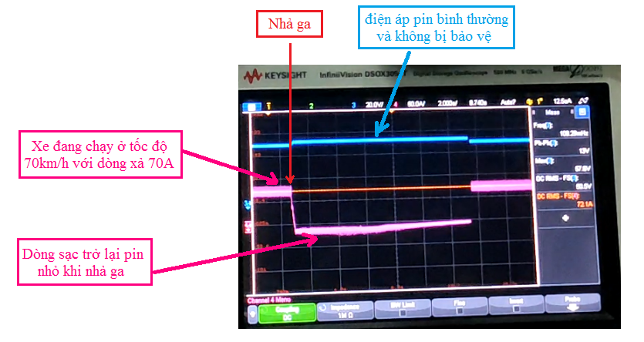

*DC Current and Voltage when release throttle suddenly at high speed (up to 90km/h)*

* 1. **Drop down freely on a slope at high speed (up to 90km/h)**

**Test goal:**

* To check the ability of control and protection of the MCU when vehicle drops freely on a slope at maximum speed.
* Based on the measured parameters: DC voltage, DC current, phase current, electrical power, mechanical power, torque, speed and MCU’s heatsink temperature. Then the ability of control and protection can be tested.
* To compare quality of Vinfast MCU and Curtis MCU.

**Test procedure:**

* MCU and Motor must be cooled down to ambient temperature before the test
* Setup the dynamometer system operates as a pulled motor to rotate Ashwoods motor with the same direction of normal operation of vehicle.
* Release throttle completely.
* Increase motor speed gradually by the force from dynamometer system (simulate the case that vehicle is drop freely on a slope) until:
  + DC Bus voltage increases higher than 63V
  + Motor speed reaches 60km/h, 70km/h, 80km/h, 90km/h
* Activate / inactivate brake signal to test charge current and protection function when DC bus voltage increase higher than over voltage protection threshold.
* The set of lead-acid battery may be used in this test because the DC power source cannot receive energy from motor.
* Log the following data for analysis: battery voltage, battery current, electrical power, torque, speed, mechanical power, temperature on heatsink of the MCU.
* Monitor DC voltage signal, DC current signal, phase current signal by oscillo scope and capture some pictures of these signal (if oscillo scope is available)

**Test plan:**

* Do the test for Vinfast MCU at least 1 time.
* Do the test for Curtis MCU at least 1 time.
* Expected time for each test is around 10 to 15 minutes.
* Total time for this test is about 1 hours

**Equipment for Test:**

* Dynamometer with control software system.
* Data acquisition system to log the following data: battery voltage, battery current, electrical power, torque, speed, mechanical power, temperature on the MCU’s heatsink.
* Ashwoods motor.
* DC Power source that can supply DC voltage from 40V to 60V and max. current should be greater than 150A.
* A set of lead acid battery (48V – 100Ah) can be used instead of DC power source but it will be inconvenient because it will take too long time to charge
* Mechanical tools.
* Oscillo scope that have 1 channel to measure DC voltage and 1 to 2 channels for current measurement.
* Fan to cool down MCU and Motor after each test
* Thermometer to measure temperature on the MCU’s heatsink

**Test results:**

* + Oscillo scope will show DC Bus voltage and Current in this operation mode.

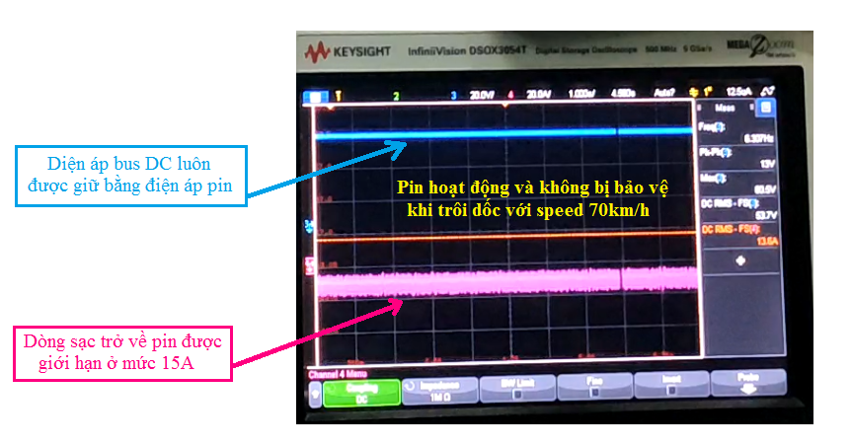

*DC Current and Voltage when vehicle drop down on a slope at high speed (up to 90km/h)*